📋 Objective

Chat Handling & Flagging SOP
Updated: @August 29, 2025​

Objective
To outline standardized procedures for handling support chat interactions, ensuring high-quality and consistent support. This SOP applies to all agents managing customer chats via Yellow.AI.
For emails
Once it is decided that a user's issue needs to be flagged, follow the flagged process > paste the flagged URL in the flagged box [Details > "Flagged Link"], send the Holding message, and change the status to ON-HOLD.
For chats
Once decided that a user's issue needs to be flagged, follow the flagged process > paste the flagged URL in the flagged box [Details > "Flagged Link"] and send the Holding message > assign the chat to the FLAGGED QUEUE and agent Mukesh Kumar.
Holding Message:
[Macro name - flagged_holdingnote]
“After carefully reviewing your issue, we’ve determined that it needs to be escalated to our internal team for a thorough check. We’ve raised it with the concerned team, and typically this process takes less than 48 hours. In rare cases, it may take up to 72 hours. Please rest assured—we’ll keep this chat open and update you as soon as we have a resolution.”
Once flagged, the internal flagged team will take over. General guidelines:
- If the chat is active → Respond to the customer and try to solve
- If the chat is inactive → Follow up with the internal team.
- If the team replies → Update the customer.
- If no reply → Mark “no update” in internal notes till next follow-up
Escalation if Delayed
If a flagged chat goes beyond 2 days without resolution → Highlight it to the leads: @Parth Saluja @Vishal @Trishala @Shanon @Twinkle @Ashad @Shalm @Govind @Sanil Sharma
Also, reply appropriately to the customer, e.g., “This is taking longer than expected, but our team is actively working on it. We apologize for the delay.”
Keep the chat flagged and ensure resolution.

Use this table to determine when to mark a chat as resolved or to flag it.
 | Scenario | ✅ Mark as Resolved | 🚩 Flag
 | When an issue is fully solved, and the user has confirmed | ✅ | ❌
 | Feedback or feature request shared | ✅ | ❌
 | The refund/replacement has been processed | ✅ | ❌
 | Waiting for the user’s reply after the partial solution | ❌ | ❌
 | Distress related to the ring, causing burns, shock, or any injury to the user | ❌ | ✅
 | Bug reported/ tech issue, pending internal fix | ❌ | ✅
 | Transaction/refund issues that need finance review | ❌ | ✅
 | Ops issues (ETA, customs, lost packages, RTO, SKU, engraving, tracking link issues) or Finance/Refund-related cases | ❌ | ✅
 | Central requests | ❌ | ✅
 | The customer query cannot be resolved with standard troubleshooting | ❌ | ✅
 | An escalation is needed to unblock progress | ❌ | ✅

⛳ Flagging

Flagging
💡You can find the list of the company-wide POCs here.
To streamline our workflow, we've implemented the following protocol for handling flagged chats.
Important to note:
- Associates must appropriately tag any newly flagged chat and move it to the flagged queue.
- The assigned agents will manage flagged thread follow-ups by:
  - Following up with the internal team on the relevant threads at intervals.
  - Updating users only if there’s a new update.
If there is an update:
- Relay the same to the users and snooze the chat for the customer’s reply.
- Reassign the chat back to the main queue.
Once the user responds and the chat reopens, it will be treated as a regular live chat and should be handled by associates. If it needs to be flagged again, the same process applies.
Setting Expectations When Flagging
Whenever we are flagging for the below reasons, let's make sure we set clear expectations with the user that we will get back to them with an update within the following timelines:
Logistics ETA: 24-48 hours
Customs: 2-3 working days
Shipment redirection: 2-3 working days
Label: 24-48 hours
Refund: 3-5 working days (for refund initiation from finance)
Invoice validation: 2-3 working days
Tech: 24-48 hours
Legal: 2-3 working days
In case there is no update from the team by the end of this duration, we can drop the user a message/email asking them for more time.

🚚 Ops

Ops
We flag ETA/expedite requests, customs issues, address or SKU changes, and order-related concerns to the Ops Team via the appropriate Slack channels.

Delayed Orders/Shifting ETA
If a user reports that their order is delayed and the estimated delivery date keeps changing, follow this process:
- Escalate the request to the Ops Team clearly stating the user’s order details and highlighting that the ETA is shifting frequently, tag the appropriate POC on the #cx_ops_escalations Slack channel, react to the thread with the ticket emoji (🎫), and fill out the form.
- Once all details are filled, copy the link to the flagged thread and paste the flagged URL in the flagged box [Details > "Flagged Link"], so the team can easily track and manage the request.
- Add the Flagged_Ops tag.
- Send the chat to the ‘Flagged Queue’ for follow-up.

Order reroute requests
If a user’s ring has already shipped and they wish to change the delivery address, please follow this process:
Advise the user that they can directly update their delivery address using the appropriate carrier’s online tool. This is the recommended first step, as it is quick and straightforward.
Available Services:
- USPS My Choice: For shipments within the United States.
- FedEx Delivery Manager: For shipments to the UK and EU.
- DHL ODD (On Demand Delivery): For all DHL-served countries.
We have ready-to-use macros for each carrier on Yellow.AI. Use the following commands to quickly provide users with the correct instructions:
- addresschange_usps
- addresschange_fedex
- addresschange_DHL
These macros contain step-by-step guidance for the user to modify their address through the carrier’s platform.
If the user is unable to change the address using the above tools, or if the carrier’s platform does not support the requested change:
- Escalate the request to the Ops Team for manual intervention by tagging the appropriate POC on the #cx_ops_escalations Slack channel, reacting to the thread with the ticket emoji (🎫), and filling out the form.
- Once all details are filled, copy the link to the flagged thread and paste the flagged URL in the flagged box [Details > "Flagged Link"], so the team can easily track and manage the request.
- Add the Flagged_Ops tag.
- Send the chat to the ‘Flagged Queue’ for follow-up.
💡Encourage users to use the carrier’s address change tool first, utilizing the relevant macro for guidance. If this is not possible, promptly flag the request to the Ops Team for further assistance.

SKU/Order Edits
For any edits made to an order that hasn’t shipped yet, post a notification on the #ring_size_edit_notifs Slack channel.
Include the UHR, the purchase email address, and a brief description of the change. Be sure to tag @harshita shetty in your message.

Customs
When users face customs-related issues with their ring shipment, it’s important to address their concerns clearly and guide them through the next steps.
💡Note:
- Customs charges are determined by the destination country’s government and apply to any product shipped internationally.
- The customs department may contact users for additional information (e.g., full name, government ID) to clear the shipment.
Common User Phrases:
- “My ring is stuck in customs.”
- “I am being asked to pay an additional amount to get the ring delivered.”
- “I am being asked to pay customs charges again for a replacement ring.”
1. The user Is Asked to Pay Customs Charges
Explain that customs charges are standard for international shipments and must be paid for delivery to proceed.
Sample Response:
We understand your concern. However, we want to clarify that while we do our best to provide transparency about potential customs charges, these fees are determined and levied by your country's customs department and are beyond our control. Once the payment is made, your order will be delivered.
2. The Ring Is Stuck in Customs Clearance
Advise the user to check their email (including spam/junk folders) for a message from DHL requesting documents or information for customs clearance.
Sample Response:
Please check for an email from DHL regarding this order. They will have sent you a link with the customs clearance requirements. You can share those details with them, and your order will be processed accordingly.
3. The user Is Charged Customs for a Replacement Ring
Replacement rings are shipped Delivered Duty Paid (DDP), so users should not be charged customs fees. If a user is asked to pay, escalate the issue.
Action Steps:
- Ask for a screenshot of the email/message that was sent to the user by DHL
- Flag the case to @Mario on the #cx-ops-escalations Slack channel, share the screenshot, react to the thread with the ticket emoji (🎫), and fill out the form.
- Once all details are filled, copy the link to the flagged thread and paste the flagged URL in the flagged box [Details > "Flagged Link"], so the team can easily track and manage the request.
- Add the Flagged_Ops tag.
- Send the chat to the ‘Flagged Queue’ for follow-up.
Mario will provide an affidavit to share with the user. The affidavit will help ensure the order is delivered without extra charges.
Quick Reference Table:
Scenario | User Action Needed | Team Action/Response
Asked to pay customs charges for a new order | Pay the customs fee | Explain charges are standard and required for delivery
Ring stuck in customs | Check DHL’s email, provide details | Guide user to complete the customs clearance process
Charged customs for a replacement ring (DDP) | Inform support team (us) | Escalate to Mario; provide affidavit to user

If you need further assistance or clarification, reach out to the designated POC (Mario) or escalate as outlined above.

Delivered but Not Received
When a user reports that their Ultrahuman Ring AIR is marked as delivered but has not been received, follow this structured process to ensure a swift and clear resolution.
Common User Statements:
- "I am unable to find the parcel with the ring."
- "The shipping link says that the ring has been delivered, but I have not received it."
Step-by-Step Process:
- Check the tracking status in the Order Management System (OMS) to confirm the ring is marked as delivered. Request that the user check with neighbors, household members, building security, or reception to see if the parcel was received on their behalf.
- If the user still cannot locate the package, flag it to @Mario on the #cx-ops-escalations Slack channel, request a proof of delivery document, and provide a brief explanation of the case, react to the thread with the ticket emoji (🎫), and fill out the form.
- Once all details are filled, copy the link to the flagged thread and paste the flagged URL in the flagged box [Details > "Flagged Link"], so the team can easily track and manage the request.
- Add the Flagged_Ops tag.
- Send the chat to the ‘Flagged Queue’ for follow-up.
Once received, share the proof of delivery with the user and ask them to check again for the package. If the user still cannot find the ring after reviewing the proof of delivery, proceed to process a replacement for them.
Additional Scenarios:
- If the delivery is still scheduled (not delivered):
  - Inform the user to contact the delivery partner directly for updates.
  - If the user faces issues connecting with the delivery partner, advise them to reach out to our support team for further assistance.
💡Tips:
- Always verify the delivery status before escalating.
- Encourage users to check all possible locations and with anyone who might have accepted the parcel.
- Escalate unresolved cases promptly to the operations team for proof of delivery.
- Only process a replacement after all checks and proof of delivery steps are completed.
- Maintain clear, empathetic communication throughout the process to reassure the user.

Incorrect Ring Delivered
When a user reports receiving a ring in the wrong size or color, follow this structured process to resolve the issue efficiently:
Step-by-Step Process:
- Ask the user to share a clear image of the back of the ring’s box. This image is needed to verify the serial number and confirm the product details.
- Use the serial number from the image to search in the Order Management System (OMS). Check if the item shipped matches the user’s original order and confirm whether the wrong size or color was sent.
- If the wrong item was shipped, flag the case on the #cx-ops-escalations Slack channel, clearly state that the ring was delivered to the wrong person, and provide all relevant details (serial number, order number, user’s information), react to the thread with the ticket emoji (🎫), and fill out the form.
- Once all details are filled, copy the link to the flagged thread and paste the flagged URL in the flagged box [Details > "Flagged Link"], so the team can easily track and manage the request.
- Add the Flagged_Ops tag.
- Send the chat to the ‘Flagged Queue’ for follow-up.
Once the operations team confirms the error, initiate a replacement order for the user with the correct ring size and color. Make sure we create an RTO request for the incorrect ring.
💡Tips:
- Always verify the serial number before proceeding.
- Keep the user informed at each step and provide clear instructions for returning the incorrect item.
This ensures that users receive the correct product and that inventory discrepancies are addressed efficiently.

💸 Finance

Finance
We flag PayPal refunds, Bank transfers, GST/Business Invoice generation, and refund issues to the Finance Team on #cx-finance.
💡Finance processes refunds on Monday, Wednesday, and Friday. We need to follow up accordingly.

PayPal refunds
For any international order not purchased directly from our website, or if a refund can’t be processed via the OMS, escalate the request to the Finance team for a PayPal refund.
Steps:
- Request from the user: PayPal email address, full name, and purchase receipt.
- Flag to Finance: Tag @fin-payments on the #cx-finance Slack channel, react to the thread with the ticket emoji (🎫), and fill out the refund form.
- Include the 6% PayPal transaction fee when creating the ticket.
- Once all details are filled, copy the link to the flagged thread and paste the flagged URL in the flagged box [Details > "Flagged Link"], so the team can easily track and manage the request.
- Add the Flagged_Finance tag.
- Inform the user that their refund request has been submitted, and you’ll update them once it’s processed.
- Send the chat to the ‘Flagged Queue’ for follow-up and resolution.

Bank Transfers
For Indian orders not purchased directly from our website, or if a refund can’t be processed via OMS, escalate the request to Finance for a bank transfer refund.
Steps:
- Request these details from the user:
  - Name
  - Bank account number
  - IFSC code
  - Name of bank
  - Purchase receipt

- For US/EU/UK/UAE/CA/AU users, keep a bank transfer as the first preference rather than PayPal. We need to collect:
  - Beneficiary bank name
  - Bank account number
  - Routing number or SWIFT code
  - Purchase receipt

- Flag to Finance: Tag @fin-payments on the #cx-finance Slack channel, react to the thread with the ticket emoji (🎫), and fill out the refund form.
- Once all details are filled, copy the link to the flagged thread and paste the flagged URL in the flagged box [Details > "Flagged Link"], so the team can easily track and manage the request.
- Add the Flagged_Finance tag.
- Inform the user that their refund request has been submitted, and you’ll update them once it’s processed.
- Send the chat to the ‘Flagged Queue’ for follow-up and resolution.

GST Invoice Generation
When a user requests a GST invoice, follow these steps:
- Collect the following details from them:
  - Customer name
  - Billing address
  - Shipping address
  - GST number
- Next, find the Shopify ID by searching for the order in Ring Order Management > Ring Orders, then locate the order and click on ‘View’ to obtain the ID.
- Once you have all the required information, send it to the Finance team along with the status of dispatch (note: a tax invoice can only be raised after the product has been dispatched).
- Flag to Finance: Tag @fin-invoice on the #cx-finance Slack channel, react to the thread with the ticket emoji (🎫), and fill out the relevant form.
- Once all details are filled, copy the link to the flagged thread and paste the flagged URL in the flagged box [Details > "Flagged Link"], so the team can easily track and manage the request.
- Add the Flagged_Finance tag.
- Inform the user that their refund request has been submitted, and you’ll update them once it’s processed.
- Send the chat to the ‘Flagged Queue’ for follow-up and resolution.

🧑🏽‍💻 Tech

Tech
We flag technical issues related to firmware, app errors, and unusual ring problems that cannot be resolved through standard troubleshooting to the Tech Team on #support-tech-oncall-requests.

General Tech Issues
For issues related to firmware, app errors, and unusual ring problems that cannot be resolved through standard troubleshooting:
- Tag @tech-oncall or @firmware on the #support-tech-oncall-requests Slack channel, react to the thread with the ticket emoji (🎫), and fill out the form.
- Once all details are filled, copy the link to the flagged thread and paste the flagged URL in the flagged box [Details > "Flagged Link"], so the team can easily track and manage the request.
- Add the Flagged_Tech tag.
- Inform the user that their issue has been flagged to our tech team, and that we’ll get back to them as soon as we have an update.
- Send the chat to the ‘Flagged Queue’ for follow-up and resolution.

Addressing Step Count Discrepancy (Incorrect Movement Index)
When users notice a discrepancy in step counts—internally referred to as an "Incorrect Movement Index"—it's important to understand why this occurs and how it is addressed.
Why Step Counts Differ Across Trackers?
Several factors contribute to variations in step count readings between different fitness trackers:
- Algorithms: Each company uses unique algorithms to interpret sensor data and convert it into step counts. This can result in differences even when devices are worn simultaneously.
- Sensors and Placement: The type and placement of sensors on each device significantly influence accuracy. For example, a ring-based tracker like Ultrahuman relies on hand and arm movement, while wrist or hip-worn devices may use different motion cues.
- Motion and Movement Patterns: The Ultrahuman ring’s step tracking is especially sensitive to arm swinging. Activities with minimal arm movement may register fewer steps, while exaggerated arm motion could increase step counts.
Acceptable Range and Resolution:
  - A difference of 1,000–2,000 steps between trackers is generally considered acceptable due to these inherent variations.
  - This is not classified as a technical issue if all troubleshooting steps (firmware update, fit check, factory reset) have already been completed.
  - The accuracy of step tracking can only be improved through future firmware updates, not immediate technical fixes.
User Communication and Feedback:
Reassure users that their feedback and data points are valuable and will be shared with the development team. Let them know that the team is continuously working to enhance step-tracking accuracy in upcoming firmware releases.
Macro for User Response:
Different trackers can vary in accuracy due to several factors:
- Algorithms: Each company uses its algorithms to interpret sensor data and convert it into steps.
- Sensors and Placement: The types of sensors used and where they are placed on the device can greatly affect step-tracking accuracy.
- Motion and Movement: In the case of the Ultrahuman ring, its design relies on arm movement for step tracking. If there isn't much arm swinging during an activity, the step count might be lower, or more if there's more swinging motion.
It's generally acceptable to have a difference of 1–2k steps in this context. We take user feedback seriously, and your specific data points are extremely helpful. We'll be sure to share this information with our development team as they continuously work on improving the accuracy of our step-tracking algorithms in future updates.
Summary:
If all troubleshooting steps are complete and the only concern is a step count discrepancy, no further escalation is required. Advise users accordingly and assure them that their feedback is valued for ongoing product improvement.

Handling Unsuccessful Cardio Adaptability Measurements
If a user reports that their Cardio Adaptability measurement was unsuccessful, follow these steps to resolve the issue efficiently:
1. Complete Troubleshooting Steps (TS)
- Ensure that all troubleshooting steps have been performed as outlined in the Notion guidelines.
- If every step has been completed, do not escalate or flag the issue further.
2. Check PPG Data Read Failures
- Review the PPG Data Read Failures dashboard to identify the specific reason for the measurement failure. This can provide insight into whether the issue is due to sensor read errors, user movement, or other factors.
3. Confirm App Version
- Verify that the user is running the latest version of the Ultrahuman app. Outdated app versions can cause measurement and data sync issues.
Summary Table:
Step | Action Required
Troubleshooting Steps | Complete all steps as per Notion guidelines.
Escalation | Do not flag if all TS are done.
PPG Data Read Failures | Check the dashboard for the reason behind the unsuccessful measurement.
App Version | Ensure the user is on the latest app version.

By following these steps, you can efficiently address Cardio Adaptability measurement failures and provide users with clear guidance, minimizing unnecessary escalations.

Social JetLag: Calibrating Status and Escalation Guidelines
If a user’s Social JetLag metric is showing as “calibrating,” it is not necessary to flag this issue in the following scenarios:
1. Frequent Timezone Changes
- If the user has changed their time zones multiple times during the week, the Social JetLag metric may remain calibrating. This is expected behavior, as frequent time zone changes disrupt the consistency required for accurate calculations.
2. Missing Sleep Indices
- The Social JetLag calculation requires at least one sleep index from both a free day and a work day. If there are missing sleep records for either type of day, the metric will continue to show as calibrating until sufficient data is available.
Summary Table:
Scenario | Action Required
User changed timezones frequently in the week | Do not flag
Missing sleep indices (work/free day) | Do not flag
Note:
Social JetLag relies on consistent sleep data across different types of days and stable timezone information. Advise users to maintain regular sleep tracking and minimize unnecessary timezone changes for best results.

Cycle Tracking & Ovulation: Troubleshooting and Escalation Guidelines
When addressing user concerns related to cycle tracking and ovulation, it’s important to know which issues require escalation to the tech team and which do not. Here’s a clear breakdown:
When to Escalate
- Technical issues with the PowerPlug, firmware updates, SR/FR, or re-onboarding the PowerPlug:
Standard troubleshooting steps like updating firmware or re-onboarding will not resolve technical issues related to cycle tracking or ovulation. Such cases must be flagged for the tech team for further investigation.
When NOT to Escalate (Do Not Flag)
1. Period Logging Limitations
- Issue: The User cannot log a period longer than 10 days.
- Reason: The system only accepts period lengths between 3 and 10 days. This is a known limitation and not a technical fault.
2. Incorrect Predicted Period Days
- Issue: User finds their predicted period days are inaccurate.
- Resolution: Users can manually log their period by tapping the calendar icon next to the ‘edit cycle details’ button. The system will then recalculate phases based on the new data.
3. Missing Temperature Data in Cycle Tracking
- Issue: User notices some days have missing temperature data.
- Explanation: If the temperature deviation from the baseline is very close to zero, no bars will appear on the graph, and the app may display “- -” for that day. This is expected behavior and not a technical error.
4. Persistent "In Calibration" Banner
- Issue: User sees the "in calibration" banner even after logging data for three cycles and wearing the ring consistently.
- Explanation: The "In calibration" status appears if the system cannot determine fertility with high confidence, based on several internal factors. This is not a technical issue.
5. Changing Predicted Ovulation Window
- Issue: User observes that their predicted ovulation window changes from day to day.
- Explanation: The ovulation prediction algorithm uses three biomarkers (temperature deviation, resting heart rate, and heart rate variability). If these biomarkers indicate a different pattern, the predicted window may dynamically update. This is expected.
6. Temperature Differences Between Sleep Index and PowerPlug
- Issue: User sees different temperature readings in the Sleep Index and Cycle Tracking sections.
- Explanation:
  - The Sleep Index temperature excludes naps, showing the average for the main sleep period.
  - The Cycle Tracking temperature includes all sleep data (including naps), which can cause differences between the two values.
Summary Table:
User Issue | Escalate? | Reason/Resolution
Technical issue with PowerPlug/firmware/SR/FR | Yes | Requires tech team intervention.
Cannot log period >10 days | No | System limitation (3–10 days).
Predicted period days seem incorrect | No | User can manually log period; system will update.
Missing temperature data in cycle tracking | No | Zero deviation = no bars; “--” is expected.
"In calibration" banner persists | No | Shown when system lacks high confidence in fertility prediction.
Predicted ovulation window changes | No | Algorithm dynamically updates based on biomarkers.
Different temperatures in Sleep Index vs. PowerPlug | No | Sleep Index excludes naps; Cycle Tracking includes all sleep data.

When flagging a technical issue with the PowerPlug/firmware/SR/FR:
- Tag @tech-oncall or @firmware on the #support-tech-oncall-requests Slack channel, react to the thread with the ticket emoji (🎫), and fill out the form.
- Once all details are filled, copy the link to the flagged thread and paste the flagged URL in the flagged box [Details > "Flagged Link"], so the team can easily track and manage the request.
- Add the Flagged_Tech tag.
- Inform the user that their issue has been flagged to our tech team, and that we’ll get back to them as soon as we have an update.
- Send the chat to the ‘Flagged Queue’ for follow-up and resolution.

Pulse Age Troubleshooting Guidelines
If a user's Pulse Age metric is missing or not updating, follow this step-by-step troubleshooting guide before escalating the issue.
1. PPG Data Collection Requirements:
Pulse Age relies on consistent, high-quality PPG (photoplethysmography) data collected during nighttime sleep. Ensure all the following conditions are met:
- The ring battery is above 20% overnight.
- The ring is not in critical battery mode during sleep.
- Background sync is enabled in the app settings.
- The ring and phone are kept close together (within Bluetooth range) overnight.
- The app is running in the background and not force-closed.
  - On iOS: Background App Refresh is enabled.
  - On Android: Battery optimization is disabled for the app.
2. Calibration and Evaluation Periods:
- Initial Calibration:
Pulse Age requires 7 consecutive days of quality nighttime PPG data for its first calculation.
- Weekly Evaluation:
Evaluations occur every Sunday. New Pulse Age results are available on Monday.
- If Pulse Age is missing this week:
The next evaluation will take place on the upcoming Sunday, with results available on Monday morning.
3. Quick Pre-Support Checklist:
Before contacting support or escalating, verify all the following:
- The ring battery is consistently above 20%
- Background sync is enabled
- App is running in the background (not killed)
- The ring and phone are within Bluetooth range overnight
- At least 7 days of quality nighttime PPG data have been collected
- Waited until Monday after the Sunday evaluation
If any of these conditions are not met, address them and monitor for updates after the next evaluation cycle.

HR/HRV Discrepancies
- Flag HR/HRV discrepancies only if the user is comparing their data to a Polar device.
- Do not flag discrepancies reported against other devices or without a direct Polar comparison, as variations between devices are expected due to differences in sensors and algorithms.
By following these steps, you can efficiently resolve most Pulse Age and HR/HRV concerns without unnecessary escalation. If all troubleshooting steps are complete and the issue persists (especially with a documented Polar comparison for HR/HRV), proceed to flag the case for further review.
Summary Table:
Issue Type | Action Required
HR/HRV discrepancy vs. Polar | Flag/escalate after verifying discrepancy.
HR/HRV discrepancy (other cases) | Do not flag; explain normal variation between devices.

This approach ensures efficient handling of user concerns while minimizing unnecessary escalations.
When flagging a discrepancy vs. Polar:
- Tag @tech-oncall or @firmware on the #support-tech-oncall-requests Slack channel, react to the thread with the ticket emoji (🎫), and fill out the form.
- Once all details are filled, copy the link to the flagged thread and paste the flagged URL in the flagged box [Details > "Flagged Link"], so the team can easily track and manage the request.
- Add the Flagged_Tech tag.
- Inform the user that their issue has been flagged to our tech team, and that we’ll get back to them as soon as we have an update.
- Send the chat to the ‘Flagged Queue’ for follow-up and resolution.

📦 Labels

Labels
For returns outside of India, we will request a return shipping label and share it with the user when an RTO (Return to Origin) is required for the ring.
💡Please note:
For an Indian RTO (Bluedart), a label is not required.
- If we need to RTO a replaced ring in India:
Select the RTO option during the replacement process.
- If we need to RTO a ring that has been refunded in India:
Please fill out the Indian RTO Typeform to proceed.

How to request a label?
Head over to Order Management > Ring Orders and locate the order. Click on ‘View’ and scroll until you see ‘Initiate RTO’ and click on it.
Then select the pickup type (Dropzone for the US, and Doorstep for ROW).
Shipment partners:
- USPS - For USA
- FedEx - For EU
- DHL - For ROW and the UK (Can make an exception for edge cases in the US that need a doorstep pick-up)
After choosing your shipment partner, select the return type and set the pickup date— if it’s a dropzone return, just enter today’s date since it doesn’t affect the process.
Next, specify the reason for the return and add any relevant pickup instructions or comments. Once all details are filled, copy the generated return URL.
Finally, once all details are filled, copy the link to the flagged thread and paste the flagged URL in the flagged box [Details > "Flagged Link"], so the team can easily track and manage the request.

Replacements
- We raise a replacement and give the user the tracking link.
- We raise an RTO request, tell the user that the labels will be sent via email, and pickup will be done. For drop-offs, they can drop off the package at their nearest USPS drop-off zone.
- Paste the Label URL in the flagged box [Details > "Flagged Link"], so the team can easily track and manage, and add the Flagged_Labels tag.
- Chat can be closed after the closing message is sent.
💡There should not be any cases where a flagged label case is kept open.

Refunds
- We tell the user that the labels will be shared via email
- Once the pickup/drop-off happens, the refund is triggered automatically. If not, the user can always reopen the chat and ask us to process it manually (Rare exception).
- Add the Flagged_Labels tag.
- Chat can be closed after the closing message is sent.
💡There should not be any cases where a flagged label case is kept open.

🌐 Others

Others

App UI related issues
For any app UI-related issues, flag the case on the #product-cx Slack channel and tag @product-team, providing a detailed description of the issue.
After flagging:
- Copy the link to the flagged thread and paste the flagged URL in the flagged box [Details > "Flagged Link"], so the team can easily track and manage the request.
- Add the Flagged_Others tag.
- Send the chat to the ‘Flagged Queue’ for follow-up.
Example:
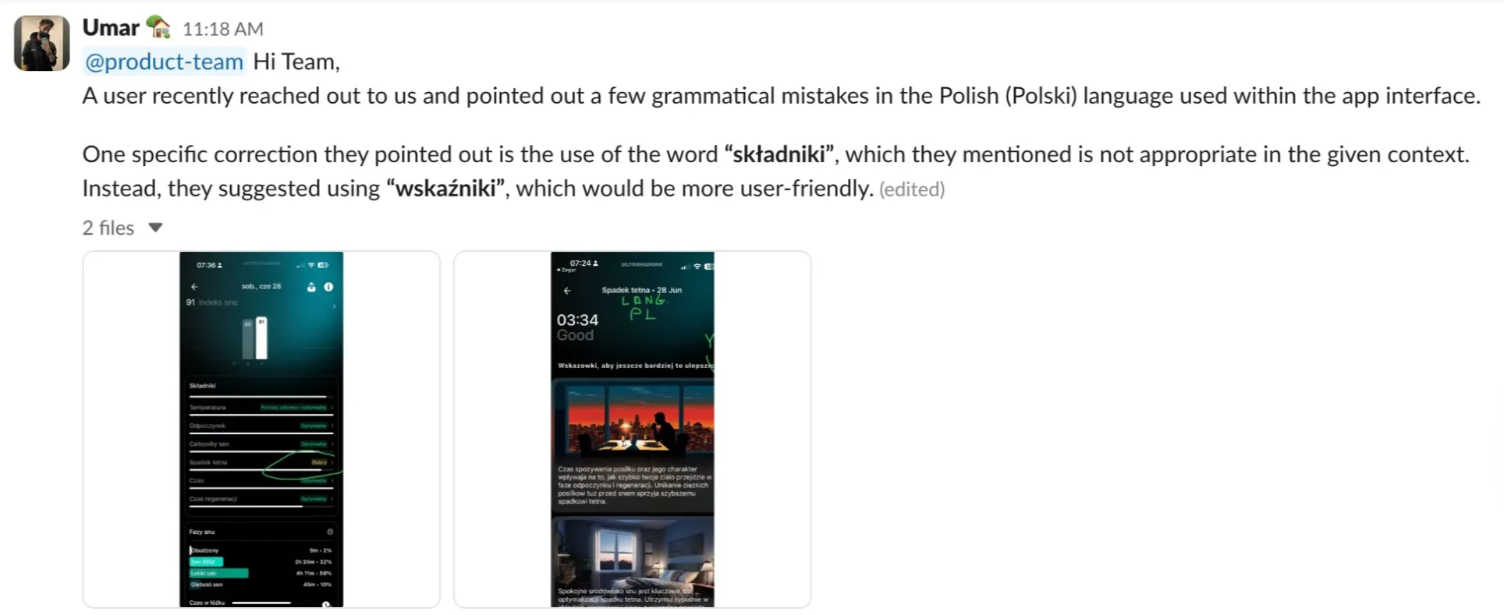

Ring hardware-related issues
For critical issues such as the ring exploding, overheating, causing burns, or similar serious concerns, immediately flag the case on the #ultrahuman-ring-cx Slack channel. Tag @mechdesign and provide a detailed description of the issue.
💡For extremely critical cases like explosions, also loop in @vmba and @legal-team to ensure prompt attention and action.
After flagging:
- Copy the link to the flagged thread and paste the flagged URL in the flagged box [Details > "Flagged Link"], so the team can easily track and manage the request.
- Add the Flagged_Others tag.
- Send the chat to the ‘Flagged Queue’ for follow-up.
Example:
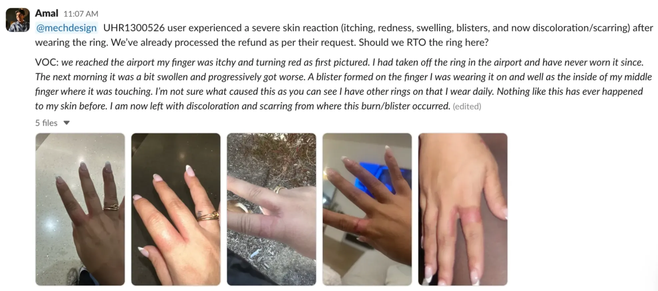

Social-related concerns
We tag @social for general queries or @influencer-marketing for influencer reachouts on the #socials-cx Slack channel.
After flagging:
- Copy the link to the flagged thread and paste the flagged URL in the flagged box [Details > "Flagged Link"], so the team can easily track and manage the request.
- Add the Flagged_Others tag.
- Send the chat to the ‘Flagged Queue’ for follow-up.
Example:
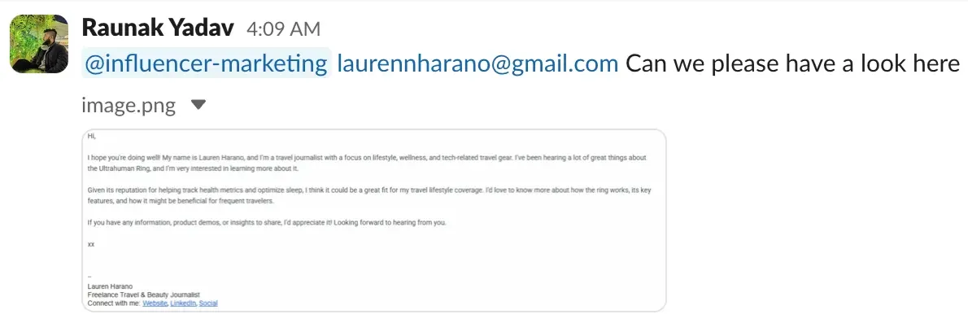

Retail partner-related concerns
We tag @retail or the relevant POC according to the email on the OMS and flag the case on the #retail-x-cx Slack channel for any retail-related concerns or to verify retail invoices.
After flagging:
- Copy the link to the flagged thread and paste the flagged URL in the flagged box [Details > "Flagged Link"], so the team can easily track and manage the request.
- Add the Flagged_Others tag.
- Send the chat to the ‘Flagged Queue’ for follow-up.
Example:
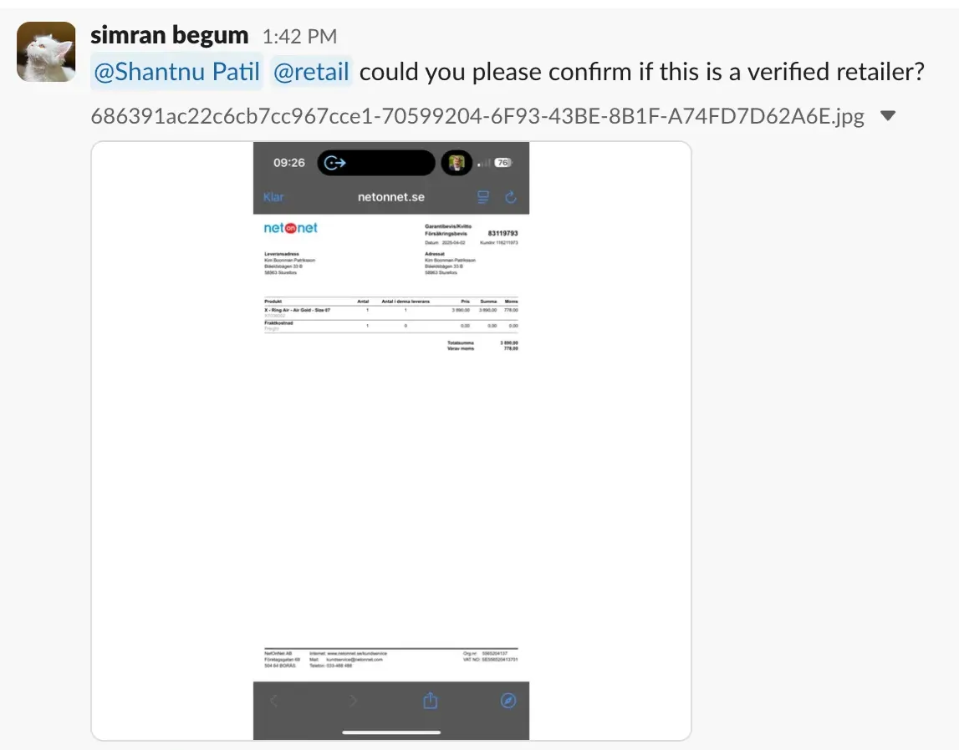

UH Home
For any tech-related issues with the UH Home device, we flag the case on the #cx-home-help Slack channel and tag Pawan/ Ashish/ Rakshita, providing a detailed description of the issue.
For product-related concerns, we flag the issue on the #kickstarter-2024-uh-home Slack channel and tag Shravani.
For ops-related issues, we flag the issue on the #kickstarter-2024-uh-home Slack channel and tag Tushar/Sarvesh.
After flagging:
- Copy the link to the flagged thread and paste the flagged URL in the flagged box [Details > "Flagged Link"], so the team can easily track and manage the request.
- Add the Flagged_Others tag.
- Send the chat to the ‘Flagged Queue’ for follow-up.

🏷️ Tagging SOP

Tagging SOP
- If a case is flagged, and then a resolution is given after, still keep the flag tags on. Don’t remove them.
- All chats should be tagged with the relevant tags based on the case.
  - random - To be used initially when you don’t know what the query is, OR in case of promotional emails/ spam emails.
  - logistics_outbound_update - When composing a fresh email to any user.
- When flagging ANY chat, follow this:
  - Flagged_Tech - Whenever chats are flagged to the tech team.
  - Flagged_Ops - Whenever chats are flagged to the Ops team.
  - Flagged_Finance - Whenever chats are flagged to the Finance team.
  - Flagged_Other - Whenever chats are flagged to any other team.
  - Flagged_Labels - Whenever we request an RTO shipping label.
- For any chats where the issue is resolved, please tag them as resolved.

🎙️ Tonality

Tonality
Always ensure that the tone of your voice is friendly, natural, and never overly apologetic. It’s a mutual process – you’re helping the user out, and the user is helping you out!
In-app chat support:
- Chat-like conversations/responses.
- Sound light, friendly, pro-active, and super helpful.
Emails:
- Generally, detailed responses (to reduce back and forth)
- Sound light, but detail-oriented, responsible, pro-active, and super helpful (users generally email us to want to escalate/complain/make themselves feel heard, so ensure you run all checks possible, and be very put together and give them closure on their queries/complaints when responding)
Social Platforms:
- Chat-like conversations/responses
- Sound light, friendly, super helpful
Some Pointers for Chat Support:
- Put yourself in the user’s shoes – Understand the challenges they are facing and show empathy.
- Be professional, warm, and friendly – Avoid being too formal or too casual to create a comfortable atmosphere.
- Keep responses clear and concise – Focus on solving the user’s query quickly, avoiding unnecessary apologies or lengthy responses.
- Avoid asking for information we already have – For example, if the user has already provided details like their device model or app version, don’t ask again.
- Respect the user’s input – If they mention they’ve already tried a troubleshooting step, don’t repeat it.
- Use solution-focused language – Instead of saying "sorry" or "apologies," focus on providing solutions.

🫱🏻‍🫲🏽 Best Practices

Best Practices
- Always tag customer messages on time. It gives everyone context about the kind of queries that come in.
- Be aware of the different macros and shortcuts already available to you. This makes resolving customer queries easier. Feel free to add macros to make your and the team's lives easier. Don’t forget to let the team know!
- When you do use macros, personalize them so that the message received by the user doesn’t sound like a template. Always aim to establish a connection with the users & ensure they feel heard.
- Always leave a summary note when flagging a chat.
- Always ensure that the tone of your voice is friendly, natural, and never overly apologetic. It’s a mutual process – you’re helping the user out, and the user is helping you out!
- Close a conversation when you’re done answering all the questions from your side.
- While attending messages on Kustomer, go back to the “Searches” page every now and then to ensure no chats have been missed.
- Never send formal responses like “Good Morning, Sir/ Ma’am”.

⚠️ Important Metrics

Important Metrics
- FRT (First response time) - Respond with a greeting like “Hey!” / “Hello!” / “Hi there!” as soon as you see a new message, to maintain your FRT.
- AHT (Average handling time) - This measures how fast you resolve queries. Be sure to prioritise your queries well. Try and cover your low-hanging fruit first, but be smart enough to identify impatient users.
- CSAT Score (Customer Satisfaction) - At the end of each chat, users are sent a short satisfaction survey. They can rate the conversation on a scale of 1-5.

